**The Decline of Symbolic Efficiency in Virtual Avatars: Exploring the Assembly of Schizophrenic Subjects in Second Life**

“Stella taught me to love myself more, so I let her be me”

(Au, 2008, p.90)

As life in the so-called ‘post-modernist’ world became increasingly more intricate and complex to decode on a daily basis (Lyotard, 1984), this had consequences for people and their search to find their place in the fast-speed procession of contemporary society. Coming as a by-product of this particular society was the experience of fragmentation of identity and loss of personal self and belonging, since as Karl Marx stated long time ago ‘all that is solid melts into air’. In respect to these factors, as well came the decline of symbolic efficiency, in the sense that images were exhausted from their symbolic power, due to constant repetition and the signifier of them vanished in a virtual simulacrum. This particular paper will probe into the symbolic efficiency of computer generated avatars, using as a main research field the virtual world of *Second Life* (2003). The research question tackled here is– how the decline of symbolic efficiency affected computer-generated avatars and in what way a platform like *Second Life* facilitates schizophrenic subjects. This is followed by sub-questions such as: how the post-modern subject became schizophrenic in his search for the Lacanian Ideal-I, and last but not least– is there a way in which the avatars can break the spell of symbolic disempowerment.

**Mediating upon Avatars in Second Life**

In this paper the research focus falls upon the sandbox virtual world *Second Life*, launched by Linden Lab in 2003. It is hard to call *Second Life* a game, since it does not fill in the description of what typical games represents, in the sense that it has no goals which it has to be achieved. That is why is being labeled as a ‘sandbox virtual world’ which implies that it is an open virtual realm, with no precise set goals, or any achievements which have to be accomplished. Since *Second Life* provides such freedom of exploration for its users, giving them a platform in which they can both live, create, and do almost anything that they can imagine (of course within game limits), this virtual world has been chosen to be explored in the lines of this paper. With a community of registered by the account of 2010, 21.3 million accounts,1 it can be said that *Second Life* is quite a popular platform, with a vast diversity of people, who are enacting their fantasies in their so-called ‘second’ life. Described by its creators Linden Lab, the platform represents a “3-D online world created and owned by its users” (Au, 2008, p.43). To illustrate better the feeling of being in Second life, one of its creators, Rosedale, stated that the making of the virtual world was similar to his experience in the Nevada desert, attending Burning Man-“the other thing about Burning Man, obviously, was that it was this huge playspace for making things. It’s just this wonderland of creative projection…” (ibid., p. 51). Hence, it can be said that *Second Life*serves as reminisce of a ‘virtual Burning man’ (ibid., p.51), where users are encouraged to share the vision of Linden Lab, with their motto- “your world, your imagination”. Soon after its initial release, the virtual platform became immensely popular, being used from individuals, to big corporations, to university institutions, where they could teach and share ideas in a new environment.

Due to time constrains, the world of *Second Life* would be explored not through personal engagement with the platform, but rather through other academic researches upon it, and through the experiences of some of its users. To begin with analyzing *Second Life* and what potentials it holds for its players, a look will be taken upon the creation of its avatars and the connection between the users and their creations.

Taken from their website, Linden Lab makes the statetement about the opportunities of creating a virtual avatar- ‘become yourself…become your avatar’ (Fig. 1).

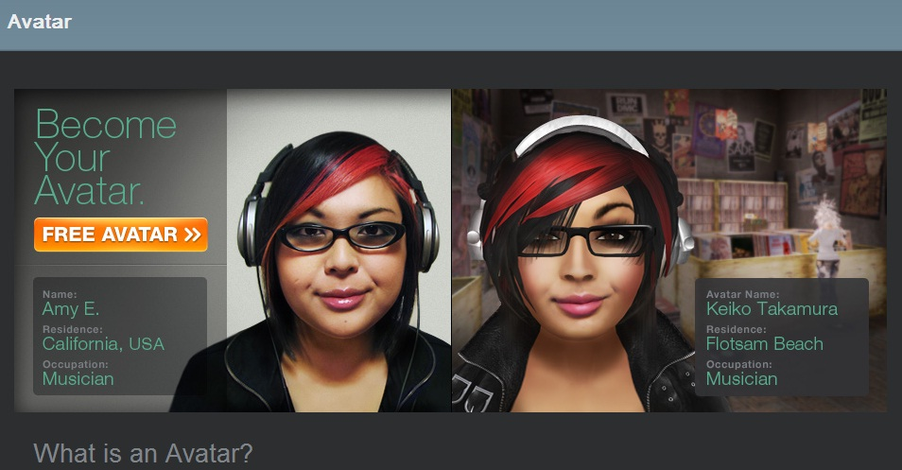

Fig.1What is an Avatar? Image retrieved from <http://secondlife.com/>

As Mark Meadows states (2008), “at its core an avatar is a simple thing..it is an interactive, social representation of a user’ (p.23). Although, is the avatar such a simple thing, as in the context of *Second Life* and the statement that you can become your avatar? Does one need/want to become as his/her avatar is the first step in order to decode this message. In *Communities of Play* is described, that embodied identities are projected upon a “player (who) have bodies over which they have some creative control and that are also persistent and evolve over time through play” (Pearce, 2011, p.19). If one has to ask, to what extent do *Second Life* avatars allow for embodied identities, it has to be acknowledged that there is a dualistic tension behind the numerous options for interaction with the avatars, and the aim to simultaneously engage the user into the notions of becoming ‘whoever he/she wants’ and ‘become yourself’.

This can be attributed to the strive of the user to find the Ideal-I, in Lacanian jargon, which means the ideal self image that the user wants to create for himself, using as a mirror his avatar. Through this identification with the mirror (the so called mirror-stage), the user wants to achieve a coherent sense of himself and to establish subjectivity, as well clear boundaries between ‘I’ and ‘You’ (Lacan, 2002). Although, in his quest to master the Ideal-I, what the user is constantly encountering is a gap between the representations he/she wants to project upon his avatar and the ideal image that he imagines to be. Precisely because the ideal ego is a sort of engulfing hole, which never satisfies the user and makes him desire more mastering upon himself, the notion of becoming ‘whoever he/she wants’ and ‘become yourself’ turns into a obscene nightmare, in which the player has no other choice but to continue playing and continue searching for his ideal projection, while constantly modifying and ‘becoming’ the image he/she desires. Thus, using the avatar as ‘cables’ the users are aiming in virtual platforms as *Second Life* to obtain their Ideal-I, which they cannot reach, and there always will be a symbolic gap between their desired image and the one that they project upon their avatars, so that it turns into an obscene journey their search through the realms of cyberspace to master not only their avatars and themselves, but as well to find their own broken subjectivity being fixed.

Continuing on, even with the great diversity of the world of *Second Life*, where player may choose not only human skins, but that of machines, animals, or creatures of fictions (Fig. 2), nevertheless still it remains an *objet petit a*,2 the promoting from Linden Lab to ‘become your avatar’.

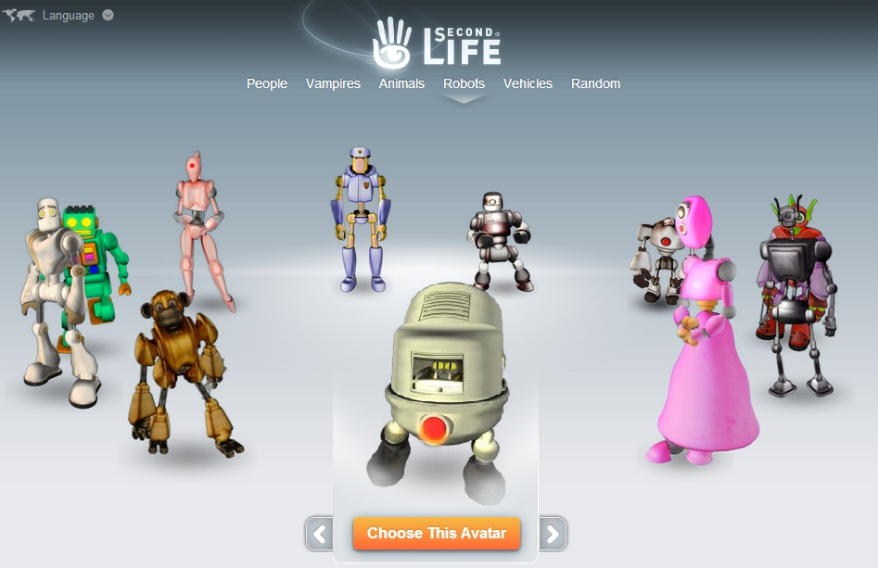

Fig.2 *Second Life* Avatar Options. Image retrieved from <http://secondlife.com/>

The notion of ‘become your avatar’ is linked to the concept of interactivity, where the user has control over how the avatar will look and will be repsented, as on Fig.2. As pointed out above about embodied identities and using the avatar as ‘cable’ to transmit through users vision of what they think their Ideal-I is, interactivity has been promoted as one of the greatest aspect of any virtual world, and the greater the options for interactivity with the surrounding world are and the avatar, the better. The notion of interactivity has not been seen by everyone in the academia as such a celebrated notion and one might say that there is a certain cult to the promotion that modern technology is made so interactive that is always ‘at hand’s reach’. It has been argued already that interactivity has become a buzzword, as quoted by Nakamura (2000)- “the fetish of interactivity is alive and well” (p.715), even after the myth of interactivity has been put into question by Slavoj Žižek. In his writings, Žižek (2008) states that what is being observed nowadays is not so much the concept of interactivity, but rather that of interpassivity. What interpassivity entails is a certain form of delegating one’s activity to an external object, in order for the person to enjoy his own passivity.

An example of this, Žižek gives with the canned laughter at sit-coms, where the viewer does not have even to laugh in order to enjoy the feeling and relief that he has laughed, since the pre-recorded audience laugh instead of him. In that way the viewer is delegating his own activity, that of laughing, to the external object- that of the pre-recorded audience, and he can achieve the same feeling as he laughed, even without pulling a muscle of his face for it (Žižek, 2008). In the light of virtual worlds and communities, it can be argued that the user is experiencing as well a certain form of interpassivity, delegating his own activity to that of his avatar. Thus, the avatar can enjoy the game and perform instead of the player, who can sit back and enjoy his own passivity, while through the external object his activities have been mediated. Serving as an example of the notion of interpassivity for *Second Life* users, is the account of Stela, who reflects that: “in a cheesy, cheesy way,” as she puts it, “Stella taught me to love myself more, so I let her be me”(Au, 2008, p.90). Hence, one does not even have to be himself/herself in order to enjoy the virtual world, free from the burden of becoming what one is.

Moreover, in order to enjoy his own creation on the screen, the player has to maintain a certain symbolical distance with his avatar, since if he tries to get too close to the object of his fixation, he might experience the trauma of the Real. This Real symbolizes as well a sublime object, which “cannot be approached too closely: if we get too near it, it loses its sublime features and becomes an ordinary vulgar object, it can persist only in an interspace, in an intermediate state, viewed from a certain perspective, half-seen” (Žižek, 1989, p.170). Hence, to maintain the fantasy that the user is a vampire-robot-walking-tree (as for extreme example) in the virtual world, one has to keep a proper distance (in order not to turn the fantasy into an ‘ordinary vulgar object’), since the user is trying to master the object, but not actually becoming the object itself. If one manages to get to his final goal (as the search for mastering the Ideal-I), the user would be satisfied, which will mean the end of his journey in the virtual realm, as *Second Life*. As one of the morals of consumer society goes, one can enjoy his satisfaction, as long as it is not satisfied. In other words- “the object only exists insofar as it is missing” (McGowan, 2008, p.6).

The drive to obtain the unobtainable is what creates desires.That is to say, desires are not the ones consumers enjoy, but rather the ones that are traumatic.This contradiction is perfectly logical in the context of any consumer product, such as the one from Linden Lab (Thomas Malaby [2009] names the consumer strategy of Linden Lab ‘creationist capitalism’), in which if actually the opportunity that the user might become what he/she wants, there is a actual risk that the desire of the user is fulfilled and he/she will switch to another product, since the player would be bored, once things are settled down. Moreover, Linden Lab experiences a paradox of “how to reconcile the contradiction between the company’s position as the entity that provides the tools and its position as the entity that provides the world in which those tools are used” (Malaby, 2009, p.59). As long as the object of mastering remains in constant flux the user will continue playing, but for an unobtainable object.

Ironically, the greatest swindle of those virtual platforms is to keep the user at bay, knowing that it is an endless path to ‘becoming your avatar’, thus making sure that the user will pay/play/consume enough of the game, even before getting close to realizing some part of his fantasies. Hence, “the object (is) drawing the subject toward a traumatic enjoyment- the enjoyment of total submission to an unattainable object” (McGowan, 2008, p.10). The object of desire- mastering eventually the avatar, achieving the highest rank, becoming the most famous avatar-hero in the given virtual world, is only worth going after, as long as it cannot be achieved. Once the boat hits the other side of the river, it will mean that the user either has to switch to another virtual world/game, or has to create another scenario/fantasy to play with. Exactly this contradiction is making a case for the production of virtual schizophrenic subjects.

**The Assembly of Schizophrenic Subjects**

In the milieu of *Second Life* it can be argued that it is serving as a machine producing schizophrenic subjects, split between their desires and the unobtainable *objet petit a*, which is the mastering of their avatars. Schizophrenia emits different connotations, but the one that it is being portrayed here yields negative side effects, such as splitting the player into a defragmented being, who appears to be lost among all the options provided by him, and in no way this serves as a liberation tool, as Gilles Deleuze argues for. In the book of Deleuze and Felix Guattari, *Capitalism A Thousand Plateaus: Capitalism and Schizophrenia* (1987),3 the condition of the user to appear schizophrenic has been portrayed as a positive aspect, since then he escapes due to his multiplicity the narrow webs of capitalism, and the constantly changing state of being of the user, which makes him an elusive creature to be entrapped in an ideological framework or any other symbolical system. This can sound as schizophrenia has such a liberatory potential, but on other hand it is overlooked that as well robs the user from any given subjective stability, which will bond him in a more less-elusive state of being, that might help him evaluate his given options better and decide for himself where to look for his broken subjectivity. What can be taken from *Thousand Plateaus*, is the notion of Deleuze‘s ‘desiring machine’, where it can be stated that *Second Life* is itself a machine for producing desires, teaching users how to desire and structure their inner self, and how to translate this in the corresponding reality.

The problem here is that due to a/the symbolic deficiency of the avatars, most of the experience gained in the virtual world is being limited to that particular realm, and does not yield, rather on some rare occasions, correspondence with the person behind the screen. As is the case of *Second Life*, it signifies that the concept serves for its users as a maligning tube for producing schizophrenic subjects, due to which it can keep them desiring the unobtainable, since their subjectivity is broken and it is more easily to offer the player constant flux of products, which promise to satisfy one or another need, but that actually creates even further wanting for ungratifying stimulus. To elucidate the point of schizophrenia in *Second Life*, James Au describes the initial frustration of users when they first start with their avatars and the search for the Ideal-I: “the combinations were nearly infinite. And often for that veryreason it was here that many users quit in frustration, overwhelmednot only by the variety of possibilities but also the challenge to create the ideal alter ego they had in their heads. (I have seen many users remain at this part of the Prelude tutorial for hours, by turns fascinated and aggravated by the options afforded them)” (Au, 2008, p.90). Thus, instead of providing liberation and satisfaction platform for its users, *Second Life* looks and behaves more as a simulacrum in which players are engulfed in ongoing proliferation of schizophrenia, to which they respond with further looking for stability and their own human subjectivity, that not only gets even more defragmenteted and obscured, but as well feels as unobtainable in the virtual realm.

Furthermore, not only it has been observed certain schizophrenic state in *Second Life*, but as well a decline of the symbolic power of avatars, which might be contributed to the post-modern era, that humans have entered. What this means for the players is that, not only they experience a proliferation of interpassivity, but as well the symbolic power of their avatars that the user hasdelegated their activity to, cannot respond properly. As Baudrillard wrote -“everything that was directly lived has moved away into a representation” (Baudrillard in Smith, 2010, p.179). With the melting of the ‘real’ into oblivion, came the notion of hyper-real, as Baudrillard claims, and the deficiency of symbolic representation. In other words- what was once a coherent set of signifiers corresponding to a solid ‘real’, nowadays it turns to vaporize in thin air, leaving the symbolic representation impotent and deficient, unable to signify itself. Hence, what virtual worlds as *Second Life* represent is a given type of simulacrum, in which everything has moved into representations, as the products here arethe avatars, but those avatars do not possess the symbolic power to transgress their own embodiment, since they have been exhausted from repetition. To give a more concrete example of the state of decline of symbolic power of images, Žižek points out to television news and the images that circulate there. He makes a case that, although the viewer can see and experience on the TV any tragic event, as war, poverty, murder and so forth, nonetheless they cannot respond properly to those images, since they are overwhelmed with the ongoing circulation of symbols, which renders the users in the end as potent receiving agents (Žižek, 2009). Thus, even that the viewer knows the tragic stories on TV, he/she can only watch, without a proper response to the pictures shown on the screen. Something similar is experienced through the creation of the avatars, which symbolic power cannot break the spell and transgress beyond the screen. This does not mean that online communities do not posses strong bonds, as organizing annual conventions or holding off-screen activities, but that the avatars themselves are stuck in their own representation loop, and the power of the liveness4 that they have been granted by the players, is only being sucked up, but cannot be utilized for producing results as fixing the users own subjectivity or creating a case for mitigating an action beyond the avatar realm.

In this state, even with such a great buzzword as ‘interactivity’ and ‘become yourself’ through the avatar, nonetheless the symbolic decline of avatars is being experienced on a large scale and this has consequences for both the users and their search for their Ideal-I. As Bauman (2009) states- “the promise of satisfaction remains seductive only so long as the desire stays ungratified” (p. 169). Hence, through this paper it can be viewed how virtual worlds as Second Life make it possible to serve as a particular desiring machine and a schizophrenic tube (a tube which sucked in as well Celia Pearce, who appears to posses split personality between herself and her avatar 'Artemesia', with whom she claimed that she co-wrote the book *Communities of Play* (2011)), which makes sure that the players remain in the loop of their desires, while feeding them with new options (such as new avatar skins, new tools to reshape their virtual environment), but nevertheless remaining on the same level of symbolic decline of the avatars and the interpassive state of their owners. Perfect statement thus would be to remark that *Second Life* signifies “nothing in the guise of something” (Žižek, 1999).

**Concluding Thoughts**

Going back to the last question part of this paper ‘is there a way in which the avatars can break the spell of symbolic disempowerment’, the answer is still dubious. On one hand as being written in this essay, that avatars are in major crisis of symbolic deficiency, entrapping the user in a constant loop of his own desires, while virtual platforms as *Second Life*, instead of resolving the schizophrenic contradiction of the user, only facilitates it and serve as a schizophrenic tube which produces desiring subjects. It will take a lot of courage to break the spell and in this particular moment it seems that the trajectory through which virtual worlds are moving are unable to transgress their own embodied impotency. Moreover, it has to be stated that this has political consequences, since in order to produce active citizens, active participation is necessary, and this active participation is not yet visible when it comes to virtual communities, who besides their own in-world agenda (of making top-ranks or saving some far kingdom), does not manage to inscribe to its users tools to return to more efficient symbolic empowerment. People will continue watching the news on their TV’s, players will continue playing through their avatars, and the world will continue waiting for somebody to manage to get a grip of a more suitable medium of expressing not delegation of vitality, but rather return to vitality which actually yields off-screen results.

**Notes:**

Data retrieved from <http://secondlife.com/> Accessed on: 22.01.2013

Objet petit a, has been summarized as the “lost object, an object that the subject separates itself from in order to constitute itself as a desiring subject” (McGowan, 2008, p.6).

For more elaboration upon the book of Deleuze and Guattari view *A User's Guide to Capitalism and Schizophrenia: Deviations from Deleuze and Guattari* (1992)

Upon the concept of ‘liveness’ and mediatized culture, view *Liveness: Performance in a Mediatized Culture* (2008) by Philip Auslander

**References:**

Au, W. J. (2008). *The making of second life: Notes from the new world*. New York: Harper Business.

Auslander, P. (2008). *Liveness: Performance in a mediatized culture*. Abigdon: Routledge.

Baudrillard, J. (1994). *Simulacra and simulation*. Ann Arbor: University of Michigan Press.

Bauman, Z. (2009). *Does ethics have a chance in a world of consumers?* London: Harvard University Press.

Bell & B. Kennedy (Eds.), *The Cybercultures Reader* (pp. pp. 712-720.). New York: Routledge.

Deleuze, G., & Guattari, F. (1987). *Capitalism a thousand plateaus: Capitalism and schizophrenia*. Minneapolis: University of Minnesota Press.

Lacan, J. (2002). *Ecrits: A selection*. (pp. 3-10). New York: W W Norton & Co Inc.

Lyotard, J. (1984). *The postmodern condition: A report on knowledge*. Minneapolis: University of Minnesota Press.

Malaby, T. (2009). *Making virtual worlds: Linden lab and second life*. Ithaca: Cornell University Press.

Massumi, B. (1992). *A user's guide to capitalism and schizophrenia: Deviations from deleuze and guattari*. Cambridge: The MIT Press.

McGowan, T. (2008). *The real gaze: Film theory after lacan*. New York: State University of New York Press.

Meadows, M. S. (2008). *I, avatar: The culture and consequences of having a second life*. San Francisco: New Riders.

Nakamura, L. (2000). Race in/for cyberspace: Identity tourism and racial passing on the internet. In D. Pearce, C. (2011). *Communities of play: Emergent cultures in multiplayer games and virtual worlds*. Cambridge: The MIT Press.

Zizek, S. (1989). *The sublime object of ideology*. London: Verso.

Zizek, S. (1999, August). The superego and the act: a lecture*.* Retrieved from <http://www.egs.edu/faculty/slavoj-zizek/articles/the-superego-and-the-act/> Accessed on: 22.01.2013

Zizek, S. (2008). *The interpassive subject*. Retrieved from <http://www.egs.edu/faculty/slavoj-zizek/articles/the-interpassive-subject/>. Accessed on: 22.01.2013